Apocalypse Card Preview: Pernicious Deed
Anthony Alongi
Let's get right down to business. Here are the four things that you should already know about Perncious Deed:

Even in Germany, they are excited by foil Deeds
1) This will be one of the two or three chase rares of the set. The natural comparison, of course, is with the classic Nevinyrral's Disk. Anything that looks like a Disk and quacks like a Disk will get chased like a Disk. Whether it gets played heavily in public arenas or not, one of the loudest screams you will hear at your drafting table is "AAAAIGHHH! I OPENED A FOIL DEED! FOIL DEED! WOOOOOO-HOOOOOO!"
Unless you are playing in France, or certain parts of Quebec, in which case you will hear "AAAAIIIIEEEE! J'AI OUVRE UN JOLI DEED! JOLI DEED! WOOOOOOO-HOOOOO!"
(Please, don't call me from France or Canada to tell me they say something besides "woo-hoo" over there. I have spent plenty of time in both France and Canada, and heard "woo-hoo" plenty often. What they were celebrating, I can't tell you. But they seemed really, really excited.)
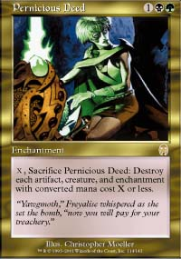
2) It will only work in green and black decks. Yes, I'm aware I'm being obvious; but it doesn't hurt to calm some of the fervor around this "new Disk". If green-black decks are not workable beyond this card, then this card will not get played, no matter how much it trades for on eBay.
One of the things we Sideboard writers said a lot with Planeshift and Invasion was, "well, this card looks good; but it depends on what else is in the set." Not only is that a beautifully convenient strategy as an analyst; it also happens to be the truth.
Of course, we know that black has had good individual cards the last two expansions - but neither black-red nor black-blue has offered a truly dominant Standard or Invasion Block deck. Green was considered decent, and unlike black was represented well in both Chicago and Tokyo. The combination of the colors represents a whole new animal, and possibly two of them; I'll talk about this more below.
3) When you open the Deed in sealed, it's like opening a Breath of Darigaaz or Rout. You don't HAVE to play the colors on the card; but you had better have a really, really good reason not to. (Hint: wanting to play Goblin Spy so you can always know what your next draw will be is NOT, I repeat NOT, a good reason.)
Of course, it's fair to ask: what the hell do you do if you open Pernicious Deed, Breath of Darigaaz, AND Rout? Well, here's my suggestion: punch yourself, hard, because that's what I'd be doing if I were sitting next to you at the tournament and you got that lucky.
4) Deed really, really wrecks Fires. It kills Birds, Elves, and Saprolings with minimal effort. If you play it on turn three, it can take out Blastoderms the following turn at instant speed. Even Shivan Wurms must beware: even if you can't activate it for five, you can still wipe out whatever the Wurm would gate back and prevent it from sticking around.
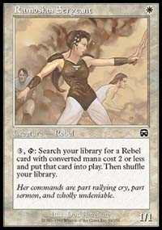
As a bonus, Deed makes Rebels' job a lot more difficult, and puts the final kibosh on Blue Skies. Netherhaups isn't exactly thrilled to see it, either, since it whacks the precious enchantments the deck relies on as a support strategy.
Even if Deed never makes it to an elite deck, the effect it will have during playtesting will force several new Standard and Block archetypes into the forefront. The same old same old just won't cut it anymore.
And now, let's look at four aspects of Pernicious Deed that are not as immediately obvious to many of us:
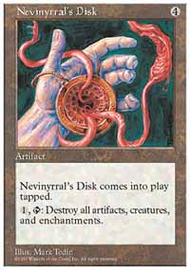
1) It has several mechanics that are significantly different from the Disk. Upon getting assigned this card to preview, I looked up "pernicious" to make sure that it meant what I thought it meant. (To my great relief, it did.) Underneath "pernicious" was the entry "pernickety", a variant on "persnickety", which means fussy about small details. You need to be pernickety if you want to be pernicious. (Okay, that's done it; I just turned into my ninth grade English teacher. Kill me now.)
While most players will look at the Deed and assume they will sweep the board the same way a Disk will every time, in fact the Deed works quite differently.
First and most prominently, the Deed sweeps at a certain casting cost level and below. That means, all things being equal, decks that use permanents with high casting costs are more resilient to the Deed's effects... and since tournament-worthy Constructed decks deal in cost-efficient cards, that's good news for the Deed.
Second, it doesn't come into play tapped, and can be used immediately. With a Disk, you would play on turn four, give your opponent(s) one full turn to do something about it, and then explode on turn five. With the Deed, you wait until turn five to play it, and then wreck everything at two mana or less. That's a completely different dynamic. Heck, with Vernal Equinox out, you could play the Deed at instant speed and... oops. Sorry, I won't talk about bad cards again. It's part of the contract The Sideboard forced me to sign.
Third, the Deed requires mana to operate effectively. Whereas the Disk was tap-and-go, you'll need to make sure you have enough mana to sweep the threats you want at instant speed. This is particularly true if you're playing it early, and against Fires.
Fourth, you can't Boomerang the Deed in response to its own activation, like you could the Disk. So all you nasty Disk bouncers can just go, um, bounce your Disks somewhere else.
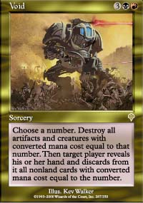
2) Green-black decks now have more bombs than red-black decks. When Invasion came out, much was made of the "Machinehead" archetype, featuring Void and Blazing Specter in gold slots, which counted on beatdown and hand disruption. But hand disruption isn't what it has been cracked up to be in the current environment. Counterrebel is the only reliable elite deck that doesn't use that many permanents - and it still has rebels! - and since most decks will use permanents, you get more information and better targeted spells if you see what you're hitting.
Of course, the biggest problem with Machinehead was that it couldn't really stop enchantments - not Fires of Yavimaya, not Saproling Burst, heck if it was lucky it nailed a creature with an Armadillo Cloak on it. But a green-black deck with Deed has a clear, reliable solution.
A potentially interesting side-by-side comparison involves the Deed and Void. While Void (at five mana) gives you a surgical sweep of the board and hand, the Deed (again, assume five mana) gives you a more thorough sweep of the board. Since the Deed can more easily kill more things, and since it gets even better as the game progresses, I give a slight edge to the Deed, and expect that it will inspire at least as many tournament decks - and, probably, greater tournament success - as Void did.
In any case, I will be interested to see if a green-black archetype takes a more controlling approach (Elliot Fertik graced a mailing list recently with an interesting green-white-black that blends regenerators like Spectral Lynx with control cards like Vindicate and Duress) or a beatdown method (focused on green-black, treating Birds of Paradise, Llanowar Dead, Ebony Treefolk, and Blastoderms as expendable resources and the Deed as a plan B if things get out of control).
Either way, we're all using Spiritmongers as closers, right?
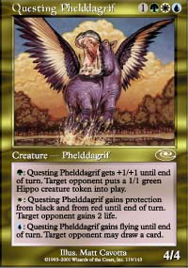
Do I go with Pernicious Deed?
3) While the Deed may look good in a green-black deck, it may look even better in a Block Domain deck. Yes, we all keep trying to find the cards that will make a domain deck work. And it can be painful to watch us do this over and over again, like lemmings running repeatedly into a wall instead of over a cliff like they're supposed to. But Apocalypse, by Mike Donais's own testimony, is supposed to be the set that really lets Domain decks work, since it contains cards that they pushed out of Invasion to delay that archetype's dominance.
I suspect the Deed may have been one of those cards. An end-of-turn Harrow on turn three (or any one of a number of elves; but why would you use suicidal elves?) will allow a Deed play and sweep for 2cc on turn four, which is a nice, selective Wrath of God for the right kind of deck. So Harrow's a great Deed accelerator, and while you're using Harrow, you may as well splash two or three more colors. Now black might not even be your secondary color; it might be a support color in a green-white deck using Spectral Lynx as I noted above. Or you might access blue and red for various domain spells, and then you'd top it off with a Global Ruin, so that the Deed's work on turn four is complemented by a massive land sweep on turn five. I'm not sure any other Standard or Block deck can accomplish that, so quickly.
4) When drafting Invasion Block, five-color green gets a boost. The likelihood that you will get a Pernicious Deed for your trouble is slight; but Pernicious Deed is at least a good representative of how we'll all draft differently for a while: when trying to decide between the Llanowar Knight and the Nomadic Elf, the nomad is looking better and better. If you don't get the Deed, you could get a Necravolver, or heck, the right kind of Disciple. Apocalypse is very much turning the Magic world upside down; and Pernicious Deed is the most obvious example of that truth.
And now, for all of you magnificent multiplayer freaks who have been waiting for me to go off on this thing, here you go:

DIRTYDEEDSDONEDIRTCHEAP.DEQ
4x Pernicious Deed
2x Wall of Blossoms
4x River Boa
4x Llanowar Dead
2x Hunting Moa (remember Hunting Moa?)
4x Fleetfoot Panther
2x Squallmonger
4x Blastoderm
2x Spiritmonger
2x Broken Fall
4x Death Grasp
Build mana to taste - I recommend at least 15 green sources, one way or the other. Some recursion in the form of Volrath's Stronghold wouldn't be the worst idea in the world, either.
The idea here is to take advantage of both the regeneration potential of a Deed deck, and play around a bit with casting cost. With ten creatures at 2cc, you can have the Deed out (and in multiplayer, it makes sense to play the Deed early and keep it out as a signal), activate it for X=2, and then shoot out a Fleetfoot to save the early weenie of your choice.
And finally,

DARNDIRTYDEEDS.DEQ
4x Pernicious Deed
4x Jolrael, Empress of Beasts
3x Yawgmoth's Agenda
1x Fastbond

And for "mana":

4x Treetop Village
4x Spawning Pool
4x Mishra's Factory
4x Stalking Stones
4x...oh, you can see where I'm going, here...

THE BOTTOM LINE
Pernicious Deed is a card built for impact, both from a tournament and casual play perspective. It is a demanding voice for you to consider black-green in limited, a playtest "must" for Standard and Block Constructed, and yet another toy for casual players to sweep the board with. It has been a long time since I have built a green-black deck; it is my favorite color combination, and I may have just seen my new favorite card.

